Safeguarding Adults Review (SAR) Framework

This document sets out how to request and conduct Safeguarding
Adults Reviews in Merton.
(under Section 44 of the Care Act 2014)

Version: 1
Effective: March 2019
Review Date: March 2020
Safeguarding Adults Review Framework
Contents:
- Introduction 3
- When should the MSAB arrange a SAR and links with other review processes 3
- What is the purpose of a SAR? 4
- What are the guiding principles for a SAR? 4
- Process; key issues 5
- Information sharing 5
- The Findings from SARs 5
- The Adult Safeguarding Multi-Agency Policy and Procedures 6
- A framework for taking forward cases that may require consideration under a SAR 8
  - Requesting a SAR 8
  - Making decisions on SAR requests 9
  - Making a decision on SAR methodology 10
  - Options for SAR methodology 12
  - Conducting the SAR 12
  - Adult/Family involvement and independent advocacy 12
  - Staff involvement 13
  - Professional conduct issues arising 13
  - SAR reports 13
  - Quality assurance of the SAR 14
  - Acting on the recommendations of the SAR 14
  - Applying learning from other SARs 15
  - Supporting and resourcing SARs

Appendix 1: Flowchart for request of a SAR 17
Appendix 2: MSAB SAR request form 18
Appendix 3: Selecting the SAR methodology 21
Appendix 4: Standard Letters 27
Appendix 5: SAR terms of reference and confidentiality template 29
Appendix 6: SAR report and action plan guidance and template 35
Appendix 7: Acknowledgements 41

1. Introduction
1.1 Section 44 of the Care Act 2014 and associated statutory guidance require Safeguarding Adults Boards (SAB) to conduct Safeguarding Adults Reviews (SARs) in certain circumstances, and permits the SAB to arrange SARs in other circumstances. The Act requires SAB member agencies to cooperate with and contribute to the carrying out of a SAR.
1.2 The purpose and underpinning principles of SARs, and the broad requirements and guidance for conducting SARs, are set out in Merton’s SAR Policy. These policy and procedures have been adopted by the Merton SAB and provide the overall governance of our SAR approach.
1.3 This SAR framework for the Merton SAB must be read in conjunction with them.
1.4 This framework has drawn on the Merton Safeguarding Adults Review framework as well as drawing directly on the statutory guidance and the Merton multi-agency policy and procedures.
1.5 The following in sections 1-6 are taken from the Care and Support Statutory Guidance and sets out the circumstances in which a SAR will be undertaken; the purpose of the SAR and the underlying principles in carrying out SARs.

2. When should the SAB arrange a SAR and links with other review processes
2.1 SABs must arrange a SAR when an adult in its area dies as a result of abuse or neglect, whether known or suspected, and there is concern that partner agencies could have worked more effectively to protect the adult.
2.2 SABs must also arrange a SAR if an adult in its area has not died, but the SAB knows or suspects that the adult has experienced serious abuse or neglect. In the context of SARs, something can be considered serious abuse or neglect where, for example, the individual would have been likely to have died but for an intervention, or has suffered permanent harm or has reduced capacity or quality of life (whether because of physical or psychological effects) as a result of the abuse or neglect. SABs are free to arrange for a SAR in any other situations involving an adult in its area with needs for care and support.
2.3 The SAB should be primarily concerned with assessing what type of ‘review’ process will promote effective learning and improve actions to prevent future deaths or serious harm occurring again. This may be where a case can provide useful insights into the way organisations are working together to prevent and reduce abuse and neglect of adults. SARs may also be used to explore examples of good practice where this is likely to identify lessons that can be applied to future cases.
2.4 When victims of domestic homicide are aged between 16 and 18, there are separate requirements in statutory guidance for both a child Serious Case Review (SCR) and a Domestic Homicide Review (DHR). Where such reviews may be relevant to SAR (e.g. because they concern the same perpetrator), consideration should be given to how SARs, DHRs and SCRs can be managed in parallel in the most effective manner possible so that organisations and professionals can learn from the case - for example, considering whether some aspects of the reviews can be commissioned jointly to reduce duplication of work for the organisations involved.
2.5 In setting up a SAR, the SAB should also consider how the process can dovetail with any other relevant investigations that are running parallel, such as a child SCR or DHR, a criminal investigation or an inquest.
2.6 It may be helpful when running a SAR and DHR or child SCR in parallel to establish at the outset all the relevant areas that need to be addressed, to reduce potential for duplication for families and staff. Any SAR will need to take account of a Coroners inquiry, and/or any criminal investigation related to the case, including disclosure issues, to ensure that relevant information can be shared without incurring significant delay in the review process. It will be the responsibility of the Chair of the SAR Panel to ensure contact is made with the Chair of any parallel process in order to minimise avoidable duplication.

- What is the purpose of a SAR?
  - SARs should seek to determine what the relevant agencies and individuals involved in the case might have done differently that could have prevented harm or death. This is so that lessons can be learned from the case and those lessons applied to future cases to prevent similar harm occurring again. Its purpose is not to hold any individual or organisation to account. Other processes exist for that, including criminal proceedings, disciplinary procedures, employment law and systems of service and professional regulation, such as CQC and the Nursing and Midwifery Council, the Health and Care Professions Council, and the General Medical Council.

- What are the guiding principles for a SAR?
  - The following principles should be applied by SABs and their partner organisations to all reviews:
    - There should be a culture of continuous learning and improvement across the organisations that work together to safeguard and promote the wellbeing and empowerment of adults, identifying opportunities to draw on what works and promote good practice;
    - The approach taken to reviews should be proportionate according to the scale and level of complexity of the issues being examined;
    - Reviews of serious cases should be Chaired/led by individuals who are independent of the case under review and of the organisations whose actions are being reviewed;
    - Professionals should be involved fully in reviews and invited to contribute their perspectives without fear of being blamed for actions they took in good faith and,
    - Families should be invited to contribute to reviews. They should understand how they are going to be involved and their expectations should be managed appropriately and sensitively.
  - SARs should reflect the six safeguarding principles. SABs should agree Terms of Reference (TOR) for any SAR they arrange and these should be published and openly available. When publishing a SAR, the records should be anonymised and (if applicable) redacted, or consent should be sought.
  - Early discussions need to take place with the adult, family and friends to agree how they wish to be involved. The adult who is the subject of any SAR does not need to be, or have been, in receipt of care and support services for the SAB to arrange a review in relation to them.
  - It is vital, if individuals and organisations are to be able to learn lessons from the past, that reviews are trusted and safe experiences that encourage honesty, transparency and sharing of information to obtain maximum benefit from them. If individuals and their organisations are fearful of SARs, their response will be defensive and their participation guarded and partial.

5. Process: Key Issues
5.1 The process for undertaking SARs should be determined locally according to the specific individual circumstances. No one model will be applicable for all cases. The focus must be on what needs to happen to achieve understanding, remedial action and, very often, answers for families and friends of adults who have died or been seriously abused or neglected. The recommendations and action plans from a SAR need to be followed through by the SAB.
5.2 The SAB should ensure that there is appropriate involvement in the review process of professionals and organisations who were involved with the adult. The SAR Panel should also communicate with the adult and/or their family. In some cases, it may be helpful to communicate with the person who caused the abuse or neglect.
5.3 It is expected that those undertaking a SAR will have appropriate skills and experience which should include:
- Strong leadership and ability to motivate others;
- Expert facilitation skills and ability to handle multiple perspectives and potentially sensitive and complex group dynamics;
- Collaborative problem solving experience and knowledge of participative approaches;
- Good analytic skills and ability to manage qualitative data;
- Safeguarding knowledge;
- Inclined towards promoting an open, reflective learning culture.
5.4 The SAB should aim for completion of a SAR within a reasonable period of time (and in any event within six months of initiating it), unless there are good reasons for a longer period being required; for example, because of potential prejudice to related court proceedings. Every effort should be made while the SAR is in progress to capture points from the case about improvements needed; and to take corrective action.

6. Information sharing
6.1 An SAB may request a person to supply information to it or to another person. The person who receives the request must provide the information provided to the SAB if:
- the request is made in order to enable or assist the SAB to do its job;
- the request is made of a person who is likely to have relevant information and then either: o the information requested relates to the person to whom the request is made and their functions or activities or;
- the information requested has already been supplied to another person subject to an SAB request for information. (paragraph 14.156 statutory guidance.)

7. The Findings from SARs
7.1 The SAB should include the findings from any SAR in its Annual Report and what actions it has taken, or intends to take, in relation to those findings. Where the SAB decides not to implement an action then it must state the reason for that decision in the Annual Report. All documentation the SAB receives from registered providers which is relevant to the CQC’s regulatory functions will be provided to the CQC.
7.2 SAR reports should:
- Provide a sound analysis of what happened, why and what action needs to be taken to prevent a reoccurrence, if possible;
- Be written in plain English; and
- Contain findings of practical value to organisations and professionals.

8. The Adult Safeguarding Multi-Agency Policy and Procedures
8.1 The procedures adopted in Merton underline the following in addition to/ support of the above statutory guidance:

8.1.1 Boards requiring information for SARs
There is an expectation that individuals, agencies, and organisations will cooperate with the review but the Act also gives Boards the power to require information from relevant parties.
8.1.2 Criminal investigations and police involvement
Where there is an ongoing criminal investigation or criminal proceedings, the SAB will need to consider, in consultation with the police, whether continuing with the SAR might prejudice their outcome and whether the completion of the SAR should be postponed until after the criminal investigation or proceedings have been completed.

8.1.3 Keeping the adult and/or their family /relevant others central to the SAR process
In non-fatal cases, the views of the adult should be central to the decision making process about the type of SAR to undertake. Communication should be established at the earliest opportunity and advocacy provided to support the adult.
The desired outcome, especially where a family is bereaved, needs to be approached with sensitivity.
Consultation and involvement needs to be balanced with the overall wellbeing of the individuals involved. Throughout the process due diligence, compassion and appropriate support should be provided and the support of relevant local authority community team should be available to provide this or an alternative arranged if more appropriate.

8.1.4 Advocacy
The local authority must arrange, where necessary, for an independent advocate to support and represent an adult who is the subject of a SAR. Where the adult is deceased, it is good practice to provide advocacy to family/friends.

8.1.5 Staff involved in informing SARs
All professionals should be fully involved in reviews and invited to contribute their perspectives without fear of being blamed for actions they took in good faith. Where an adult has died, professionals working with that adult should have the opportunity to discuss their feelings in a safe environment and offered counselling or other therapeutic support. Professional supervision may not be the most helpful means of exploring any fears or anxieties or coping mechanisms to enable professionals to take an objective view and learn from the SAR. There will be occasions when allegations are made that staff have been guilty of abuse against adults at risk.
- If the staff member is subject to a criminal investigation, consideration will need to be given to the timing of any SAR.
- If the staff member is subject to a disciplinary enquiry, it is likely that the SAR will work alongside the disciplinary enquiry.

8.1.6 Process issues
Individuals commissioned to undertake a SAR must be independent of the organisations involved. No one model of review will be applicable to all cases. The focus must be on what needs to happen to achieve understanding, take remedial action and, very often, provide answers for families and friends of adults who have died or been seriously abused or neglected. Every effort should be made while the SAR is in progress to capture points from the case about improvements needed and to take corrective action.
8.1.7 First steps in taking a SAR forward:
- Identify a SAR Chair/Lead to coordinate arrangements
- Determine a model for the review (appropriate/proportionate)
- When commissioning a SAR, the following points should be agreed:
  - Scope of the terms of reference; o Knowledge, skills and experience of the reviewer; o Timescales for completion; o Who will secure any legal advice required; o How the interface between the SAR and any other investigations or reviews will be managed; o A communication strategy, including clarification about what information can be shared, when and where (conditions);
  - A media strategy; o What the arrangements for administrative and professional support are and o How it will be paid for.
Consideration of other reviews/investigations is covered above in the statutory guidance.

8.1.8 Coroners
A SAR may need to take account of a Coroners inquiry, including disclosure issues, to ensure that relevant information can be shared without incurring significant delay. Coroners are independent judicial office holders who are responsible for investigating violent, unnatural deaths or deaths of unknown cause, and deaths in custody, or otherwise in state detention, which are reported to them. The Coroner may have specific questions arising from the death of an adult at risk. These are likely to fall within one of the following categories:
- Where there is an obvious and serious failing by one or more organisations;
- Where there are no obvious failings, but the actions taken by organisations require further exploration/explanation;
- Where a death has occurred and there are concerns for others in the same household or other setting (such as a care home);
- Deaths that fall outside the requirement to hold an inquest but follow-up enquiries/actions are identified by the Coroner or his or her officers.
In the above situations the local SAB should give serious consideration to initiating a SAR.

9. A framework for taking forward cases that may require consideration under a SAR

9.1 Requesting a SAR
9.1.1 The Merton Safeguarding Adults Board SAR Evaluation Subgroup is the only body that may commission SARs of adult safeguarding cases in Merton.

9.1.2 Any agency, professional or individual can use the process outlined below to request a SAR on a case believed to fit the criteria listed in section 2. A flowchart of the process is available at Appendix 1.
9.1.3 A case may come to notice due to (for example but not limited to): an individual worker/ volunteer notifying a manager; a serious incident or accident report; a complaint or whistle-blower; a Section 42 safeguarding enquiry; notification from the Care Quality Commission (CQC) or any other channel.
9.1.4 Where a professional or volunteer working for an agency is requesting a SAR, the request should first go through their organisation’s appropriate management structure. The organisation’s relevant senior manager and/ or representative on the SAB will then make the SAR request to the SAB SAR Subgroup. To ensure the efficient identification of appropriate cases for SAR consideration, relevant operational managers in agencies need to be aware of the criteria for a SAR.
9.1.5 If the incident triggers a mandatory investigation or review within the organisation concerned (e.g. NHS SIRI) this should take place as a matter of priority, but a referral for a SAR (if appropriate) should not be delayed and should be made at the same time. Internal governance processes and multi-agency reviews are not mutually exclusive.
9.1.6 Requests for a SAR must be made in writing using the SAR request form (see Appendix 2), which should be completed as fully as possible. The request must be sent to the Chair of the SAB SAR Evaluation Subgroup, with a copy to the relevant Director of Adult Services by either secure email or post to protect personal and/or sensitive information. The SAR Evaluation Subgroup Chair will decide whether to convene a special SAR Evaluation Subgroup meeting for a decision on whether to proceed with a SAR. If it is felt that additional information is needed to assist the panel in making a decision this will be requested.
9.1.7 The SAR Evaluation Subgroup will meet to review the request and decide whether the criteria for a SAR have been met (see section 2 and section 9.2) and, if required, to decide which SAR methodology should be used (section 9.3).
9.1.8 The Chair of the MSAB SAR Evaluation Subgroup will write to the requestor and relevant statutory Director(s) to inform them of the outcome of the SAR request and reasons for the decision (see template letter A at Appendix 4).
9.1.9 If a request for a SAR is upheld, the Chair of the SAR Evaluation Subgroup will write to the Chief Executives (or equivalent) of all relevant agencies, copied to their respective Board member, to notify them of the decision to commission a SAR and the methodology to be used (standard letter B at Appendix 3). Chief executives (or equivalent) are to make the necessary arrangements for participation in the SAR, e.g. securing files and records; nominating a representative for a SAR Panel. The Chair of the Merton SAB will also arrange for relevant commissioning and regulatory bodies to be notified that a SAR has been initiated.
9.1.10 If a request for a SAR is turned down, and where the requestor is dissatisfied with this outcome, they should notify the Chair of the Merton SAB in writing, who will discuss and review (if necessary) the decision with the requestor and the panel of Board members who decided on the initial request.
9.1.11 If a decision not to hold a SAR is upheld, the requesting agency can choose to take no further action or to undertake an internal review using an appropriate methodology. All relevant organisations must continue to implement any actions in the protection plan from any original Section 42 safeguarding enquiry.

9.2 Making decisions on SAR requests
9.2.1 In deciding whether a SAR should be conducted, the SAR Evaluation Subgroup must first consider whether there is a statutory obligation to undertake a SAR: whether the request meets the criteria outlined in section 2. A SAR must be commissioned if there is a statutory requirement to do so.
9.2.2 In cases other than those involving a statutory obligation, the subgroup should carefully consider whether commissioning a non-statutory SAR would be a valuable exercise: i.e. whether or not a multi-agency review process has the potential to identify sufficient lessons to enhance partnership working, improve outcomes for adults and families and prevent similar abuse and neglect in the future. It is vital that the intensive resources required for a SAR are focussed on those cases that will yield the greatest learning and practice development.
9.2.3 Considering the following questions may help to establish whether there are sufficient lessons to be learned and value in commissioning a non-statutory SAR:
- Was there a “near miss”?
- Does the case indicate that there may be failings in how the adult safeguarding multi-agency policies and procedures function, leading to serious concerns about how professionals/services work together?
- Did the system not recognise/ share evidence of risk of significant harm to an adult (or recognise/ share it late)?
- Is there evidence that system conditions lead to poor multi-agency working or communication?
- Does that case involve serious or systemic organisational abuse and multiple alleged perpetrators, from which learning could be transferred to other organisations to prevent such abuse or neglect in the future?
- Could the case potentially yield systems learning around how agencies work together to prevent and reduce abuse and neglect that would help to do things differently in the future?
- Would a SAR on the case enable the SAB to be proactive and pre-emptively tackle practice areas or issues before harm arises?
- Does intelligence from other quality assurance and feedback sources (e.g. audits/ complaints) suggest that the kind of issue in the case is new, complex or repetitive and that conducting a SAR would therefore be beneficial?
- Has this happened before (in Merton or elsewhere) and was a SAR commissioned then?
- Has the learning from any previous SAR been implemented or is there new learning to be identified?
- Is there, or is there likely to be, media interest or serious public concern?
- Is there evidence of sufficient good practice that could be shared across the partnership to the benefit of adults and their families?
9.2.4 The Chair of the SAB SAR Evaluation Subgroup should also consider whether another review or learning process has already been commenced that will identify and share lessons to be learned, or which the SAB could potentially feed into/from to avoid duplication (e.g. Domestic Homicide Review or health SIRI).

9.2.5 In making a decision to commission a SAR the Merton SAB SAR Evaluation Subgroup should aim for consensus, not a majority view. If the subgroup cannot come to a consensus, the final decision will rest with the Chair of the Merton SAB after carefully considering the views of all panel members.
9.2.6 If the decision whether to proceed with a SAR is unclear the Chair of the Merton SAB may discuss this with a fellow SAB Chair to obtain a peer view to refer back to the SAR Evaluation Subgroup.

9.3. Making a decision on SAR methodology
9.3.1 Once the SAB Chair and SAR Evaluation Subgroup have agreed to commission a SAR, they must decide on the most appropriate methodology to use. (See Appendix 3). How the SAR is conducted will affect the kind of learning obtained from it and whether the process is constructive and valuable. The choice of methodology is therefore significant. In selecting a review methodology, the following principles need to be considered:
- It is about learning, not holding to account
- Independence
- Trust/open and honest/ transparency/sharing information
- Involving the person and/or their family
- Involving and supporting staff/professionals involved at the time
- Making sure the learning produces real outcomes in practice for people
- Reflecting the 6 safeguarding principles (Care & Support Statutory Guidance)
- Flexibility of approach/proportionate approaches
- Answers for family/friends of those who have died/or been harmed
- Openly published where appropriate
- Timeliness - completed in 6 months from decision to hold review (unless -and give reasons)

The following are helpful elements of review approaches:
- Involvement of both frontline staff/senior managers, securing both strategic and operational perspectives
- Including perspective of staff involved in the case, reflective of systems operating at the time
- Consideration of system and practice strengths as well as weaknesses
- Learning takes place throughout the process enhancing commitment to its dissemination
- Partnership working: including mutual recognition of alternative partner perspectives and collaborative problem solving
(Based on London SAPBs 2012). Serious Safeguarding Adults Reviews:Guidance note on options for London (cited in SCIE guide 2015)
The Care Act statutory guidance indicates that, whichever SAR methodology is employed, the following elements should be in place:
9.3.2 SAR Chair – independent of the case under review and of the organisations whose actions are being reviewed, with appropriate skills, knowledge and experience:
- Strong leadership and ability to motivate others
- Ability to handle multiple competing perspectives and potentially sensitive/ complex group dynamics
- Good analytical skills using qualitative information
- A participative and collaborative approach to problem solving
- Adult safeguarding knowledge
- Commitment to/ promotion of open and reflective learning cultures
9.3.3 SAR Panel – scrutinises information submitted to the review and shapes the independent report. The panel membership should be proportionate to the nature and complexity of the review, but should comprise a minimum of three members and a support officer in addition to a Chair with a level of independence from the case under review.
9.3.4 Terms of reference – published and openly available, reviewed annually. See Appendix 5

9.3.5 Early discussions with the adult and their family, carers and friends – to agree to what extent and how they would like to be involved in the SAR, and to manage expectations. This includes access to independent advocacy if required (to be provided by the Local Authority).
9.3.6 Appropriate involvement of professionals and organisations who were working with the adult – to contribute their perspectives without fear of being blamed for actions they took in good faith.

9.3.7 SAR report and recommendations – See Appendix 6
9.3.8 Outside of these requirements, the methodology employed should be determined by and proportionate to the specific circumstances of the individual case. This implies SABs need a range of review options to match against different cases.
9.3.9 The methodology selected must offer the most effective learning and involvement of key staff/ family weighed against the cost, resources and length of time required to conduct the review.
9.3.10 The following should be considered in selecting a SAR methodology:
- Is the case complex, involving multiple abuse types and/or victims?
- Is significant public interest in the review anticipated?
- Is large scale staff/family involvement required and/or appropriate?
- Are any criminal proceedings ongoing that staff could be witnesses in, and could the SAR methodology impact on them?
- Is the type of review being suggested proportionate to the scale and level of complexity of the issues being examined?
- What is the quickest and simplest way to identify the learning?
- Is a more appreciative approach required to review good practice?
- Are trained lead reviewers available in-house or nationally for the method selected?
- Are resources available to train or commission a lead reviewer?
- Can value for money be demonstrated?
9.3.11 In selecting an SAR methodology the Merton SAB Chair and SAR Evaluation Subgroup should aim for consensus, not a majority view. If the subgroup cannot come to a consensus, the final decision will rest with the Chair of the SAB after carefully considering the views of all panel members.
9.3.12 In addition to selecting a SAR methodology, the Chair of the Merton SAB and SAR Evaluation Subgroup must also decide:
- Which agencies should be asked to participate in the SAR Panel?
- Level of independence from the case required of panel members (it is advisable that panel members have not had involvement in the case nor line management responsibility for staff writing a report for the SAR).
- Whether agencies should be required to secure their files/records.
- Level of independence required of the SAR chair (e.g. representative from another agency, external consultant etc.)
- The final detail of the Terms of Reference for the SAR will be determined by the SAR Panel. This will build on areas for inclusion as determined by the SAR Evaluation Subgroup. The TOR will include timescales for completion and how learning from the SAR will be disseminated and embedded.
- The required output from the SAR (e.g. a report, findings, recommendations).
- Whether an independent author is required, and level of independence. If so the SAB will appoint an independent author.

9.4 Options for SAR methodology
9.4.1 The selection of a methodology will take into account above considerations and make reference to the building body of experience across SAPBs. A range of models for approaching SARs is set out in the SCIE guide Safeguarding Adults Reviews under the Care Act: implementation support (SCIE 2015). See Appendix 3
The Merton SAB may decide upon another methodology that reflects the principles set out in this framework and the statutory guidance.

9.5 Conducting the SAR
9.5.1 If the SAR request is agreed, the Chair of the SAR Evaluation Subgroup will invite the preferred candidate(s) to chair the SAR Panel, and brief them on the agreed methodology, terms of reference (as identified to date by the panel) and required timescales.
9.5.2 A multi-agency SAR Panel will be set up in line with the methodology and any requirements set by the Chair of the Merton SAB SAR Evaluation Subgroup who reviewed the SAR request (see paragraph 5.6).
9.5.3 The Chair of the SAR Panel is responsible for:
- Setting SAR Panel meeting dates and agendas as required.
- Ensuring the TOR reflect any emerging issues identified early on.
- Inviting all nominated representatives from relevant agencies to SAR Panel meetings.
- Ensuring the review is conducted according to the terms of reference and methodology.
- Ensuring a satisfactory report and executive summary are agreed by the panel.
- Notifying the Merton SAB of any shortfall in administrative/ resourcing arrangements.
- On-going liaison with the police and/or coroner’s office as required.
- Arranging early discussions with the adult(s) and their family/representatives [if appropriate] and requesting the arrangement of any support they require to participate.
- Initiating the preparation and implementation of media and communication strategies as necessary, or the obtaining of legal advice.
- Requesting any data/ evidence/ reports from partner agencies as required.

9.6 Adult/family involvement and independent advocacy
9.6.1 This section must be read in conjunction with the Multi-Agency Safeguarding Adults Policy and Procedures, and Section 68 of the Care Act and associated statutory guidance.
9.6.2 Adults and/or families should be invited and supported to contribute to SARs if they wish to do so, in order that an inclusive approach is taken and that their wishes, feelings and needs are placed at the heart of the review.
9.6.3 The SAR Panel chair must attempt to make contact with the adult(s), their family and/or representatives as appropriate early in the process (ideally before the first SAR Panel meeting) to establish:
- Why and how a SAR will be undertaken into their (family member’s) case.
- How they would like to be involved – e.g. views contributed via telephone conversation, or interview, or attendance at SAR meetings.
- Any support or adjustments they would need to facilitate their involvement.
- Their initial views, wishes, concerns, and any answers/ outcomes they would like to achieve from the SAR.
9.6.4 Reasonable and appropriate support and adjustments should be made by the Merton SAB as required to enable the adult(s), their family and/or representatives to participate in the SAR.
9.6.5 If there is no appropriate person to support and represent the adult(s) and this is deemed necessary/desirable, then Councils must arrange for an independent advocate (under Section 68 of the Care Act).
9.6.6 Alternatively, if the relevant criteria are met, appropriate partners can make arrangements for an independent mental capacity advocate (IMCA) or an Independent Mental Health Advocate (IMHA) to support and represent the adult(s). If an independent advocate, IMCA or IMHA has already been arranged for the adult(s), e.g. during assessment and care support planning or for a safeguarding enquiry, then the same advocate should continue to be used.
9.6.7 It is for Merton SAB to form a judgement on a case by case basis about whether the adult(s) has “substantial difficulty” in being involved in the SAR process and about who can act as an appropriate person.

9.7 Staff involvement
9.7.1 This section must be read in conjunction with the Multi-Agency Safeguarding Adults Policy and Procedures.
9.7.2 As soon as a SAR has been agreed, staff and volunteers who have had involvement in the case should be notified of the decision by their agency. The nature, scope and timescale of the review should be made clear at the earliest possible stage to staff, volunteers and their line managers.
9.7.3 It is important that relevant staff and volunteers of all agencies are given an opportunity to share their
views on the case as appropriate to the review methodology selected. This may be as part of the IMR process. This should include their views about what, in their opinion, could have made a difference for the adult(s) and/or family. All agencies must support staff and practitioners involved in a SAR to “tell it like it is”, without fear of retribution, so that real learning and improvement can happen.
9.7.4 Agencies are responsible for ensuring their own staff and volunteers are provided with a safe environment to discuss their feelings and offering support where needed. The death or serious injury of an adult at risk will have an impact on staff and volunteers, and needs to be acknowledged by the agency. The impact may be felt beyond the individual staff and volunteers involved, to the team, organisation or workplace.

9.8 Professional conduct issues arising
9.8.1 This section must be read in conjunction with the Multi-Agency Safeguarding Adults Policy and Procedures.
9.8.2 The purpose of a SAR is not to apportion blame to an individual or an agency but to learn lessons for future practice. It is important that this message is conveyed to staff and volunteers. Issues of professional conduct may become apparent during a SAR, but it is not within the remit of the SAR Panel to deal with these.
9.8.3 Where concerns about an individual’s practice or professional conduct are raised through the SAR process, they must be fed back to the relevant agency through the SAR Panel chair. It then remains the responsibility of the individual agency to trigger any action in proportion with the concerns passed on by the SAR Panel.

9.9 SAR reports
9.9.1 This section must be read in conjunction with the Multi-Agency Safeguarding Adults Policy and Procedures.
9.9.2 The required output of a SAR – e.g. whether a report is needed, and/ or independent authorship – is to be set out in the SAR terms of reference as agreed by the Chair of the Merton SAR Evaluation Subgroup.
9.9.3 The SAR Panel Chair must ensure that there is sufficient discursive analysis, scrutiny and evaluation of evidence by the SAR Panel throughout the SAR process. The systemic and contributory factors, practice and procedural issues and key learning points identified by the SAR Panel should form the basis of any SAR report, to be produced by the nominated author.
8.9.4 A template SAR report is provided at Appendix 6
9.9.5 The SAR Subgroup should receive and agree the draft report before it is presented to the Merton SAB so that all agencies are satisfied the panel’s analysis and conclusions have been fully and fairly represented.
9.9.6 The adult(s) and/or family should also be given the opportunity to discuss the SAR report and conclusions, and their experience of the process.
9.9.7 The Merton SAB SAR Evaluation Subgroup will decide to whom the SAR report, in whole or in part should be made available and the means by which this will be done. This should include publication via the Merton SAB webpages, but could also include dissemination via the Knowledge Hub and/or regional networks. Considerations of reputational risk or national learning arising from the case may affect decisions to publish. Any reports to be published must be fully anonymised.
9.9.8 The SAB Business Manager (or equivalent) will make appropriate arrangements for the SAR report and other records collected or created as part of the SAR process to be held securely and confidentially for an appropriate period of time in line with the Merton SAB’s information sharing agreements, the Data Protection Act and other legal requirements.

9.10 Quality assurance of the SAR
9.10.1 Quality assurance is embedded throughout the SAR process, from commissioning through to SAB scrutiny of the report and implementation of recommendations. Quality assurance is also built into the SAR methodology options set out in this framework.
9.10.2 In each model it is imperative that SAR Panel members avoid agency defensiveness and arguments about minute detail of what happened. The following arrangements will help to avoid/ minimise this:
- Commissioning the most appropriate SAR methodology for the case.
- Commissioning a suitably skilled, experienced and independent SAR lead or chair to facilitate the review and analysis.
- Independence of SAR Panel members and IMR authors from the case under review.
- A focus in each model on seeking out causal factors and systems learning.
- Requirements in the terms of reference for the SAR to take a broad learning approach and to “tell it like it is”.
9.10.3 Finally, the contents of the report presented to the SAB (as set out in Appendix 6) must contain enough of the evidence, analytical techniques/ tools used and “working out” for the SAB to be able to check, scrutinise and challenge. In doing so, the SAB will gain assurance of the adequacy of the evidence, quality of the analysis and usefulness of the recommendations, but will not duplicate the work already completed in the course of the SAR.

9.11 Acting on the recommendations of the SAR
9.11.1 The Merton SAB will, through the SAR Evaluation Subgroup and with the support of the Business Manager, translate learning and recommendations from the SAR report into a multi-agency action plan if required, which should be endorsed at senior level by each organisation to whom it relates. The Board will seek assurance that individual agency action plans are carried through. The SAB may decide not to implement a recommendation(s), but must state the reason for that decision in its Annual Report.
9.11.2 The multi-agency action plan will indicate:
- The actions that are needed.
- Responsibilities for specific actions.
- Timescales for completion of actions.
- The intended outcomes: what will change as a result?
- Mechanisms for monitoring and reviewing intended improvements.
- The processes for dissemination of the SAR report or its key findings.
9.11.3 Individual agencies may also be asked by the SAB to produce and implement their own internal action plans if required.
9.11.4 Board members of the Mreton SAB are responsible for ensuring all actions are completed from their own and the multi-agency action plan, and for ensuring that learning from the SAR is embedded in their organisation and constituent agencies. However, agencies should make every effort to capture learning points and take internal improvement action where possible while the SAR is in progress, rather than waiting for the SAR report and action plan.
9.11.5 The Merton SAB will monitor progress on all multi-agency recommendations (or delegate to an appropriate Subgroup) and may request periodic progress update reports from relevant agencies, until such time that all actions have been completed.
9.11.6 In line with Schedule 2 of the Care Act, the Merton SAB will include findings from any SARs in its Annual Report, together with information on any ongoing SARs. The Annual Report will list all completed SARs, what action was taken or is intended to be taken in relation to the findings, or where the Merton SAB decided not to implement a recommendation the reasons for that decision.

9.12 Applying learning from other SARs
9.12.1 The Merton SAB is committed to the regular analysis of the themes and learning from nationally high-profile SARs and relevant other SARs as selected by the Board Manager and SAR Evaluation Subgroup.
9.12.2 The SAR Evaluation Subgroup has an embedded process for the review of SARs from outside of Merton as part of their annual work plan to ensure lessons are identified, disseminated and embedded:
- The SAB Business Manager will identify key themes and learning from SARs outside of Merton, and present summary details to the Subgroup following discussion with the chair.
- The Subgroup will review the themes and learning in Merton context to evaluate learning and identify any areas for improvement for Merton.
- The SAR information is disseminated to partners via their Subgroup member for identification and implementation of any single agency learning.
- Relevant multi-agency learning and actions identified are drawn together and presented to the SAB for discussion and consideration as part of the SAB strategic plan.
9.12.3 The SAR Subgroup may do whatever else it deems necessary and reasonable to facilitate the dissemination and embedding of this learning into practice, e.g. facilitating a learning slot at an SAB Meeting, circulating newsletters, incorporating findings into training and workshops for staff.

9.13 Supporting and resourcing SARs
9.13.1 Section 44(5) of the Care Act requires each member of the Merton SAB to co-operate in and contribute to the carrying out of a SAR, with a view to:
- Identifying the lessons to be learned from the case, and
- Applying those lessons to future cases.
9.13.2 Partners are required under Sections 6 and 7 of the Care Act to:
- Co-operate in general in the performing of statutory functions under the Care Act that relate to protecting adults with needs for care and support (and/ or carers) from abuse and promoting their wellbeing, including SARs.
- Co-operate when requested in relating to specific cases, such as SARs.
9.13.3 In addition, Section 45 of the Care Act places a duty on all partner organisations to supply information to the Merton SAB (or other specified person/body) where they are likely to have relevant information that will enable or assist the SAB in exercising its functions – including conducting SARs.
9.13.4 Resources are needed for undertaking and supporting a SAR. The statutory partners of the Merton SAB will provide resources, in cash or kind, on a shared basis to ensure that the relevant costs for each SAR can be met. These will vary according to the methodology selected – e.g. a SAR requiring the services of consultants as independent chair and independent author will be costlier.
9.13.5 The statutory partners on the Mreton SAB will also ensure that the SAR Chair and Panel receive adequate administrative support, and will take a decision on how and from whom this will be provided.
9.13.6 All partners will commit internal resources to the production of evidence for a SAR (e.g. an IMR or interviews/conversations with relevant staff) as requested by the SAR Panel.
9.13.7 The SAB Business Manager will maintain an annual overview of SAR related costs for the SAB, for consideration each year as part of the Annual Report and to aid annual budgeting.

Appendix 1: Flowchart for request of a SAR.
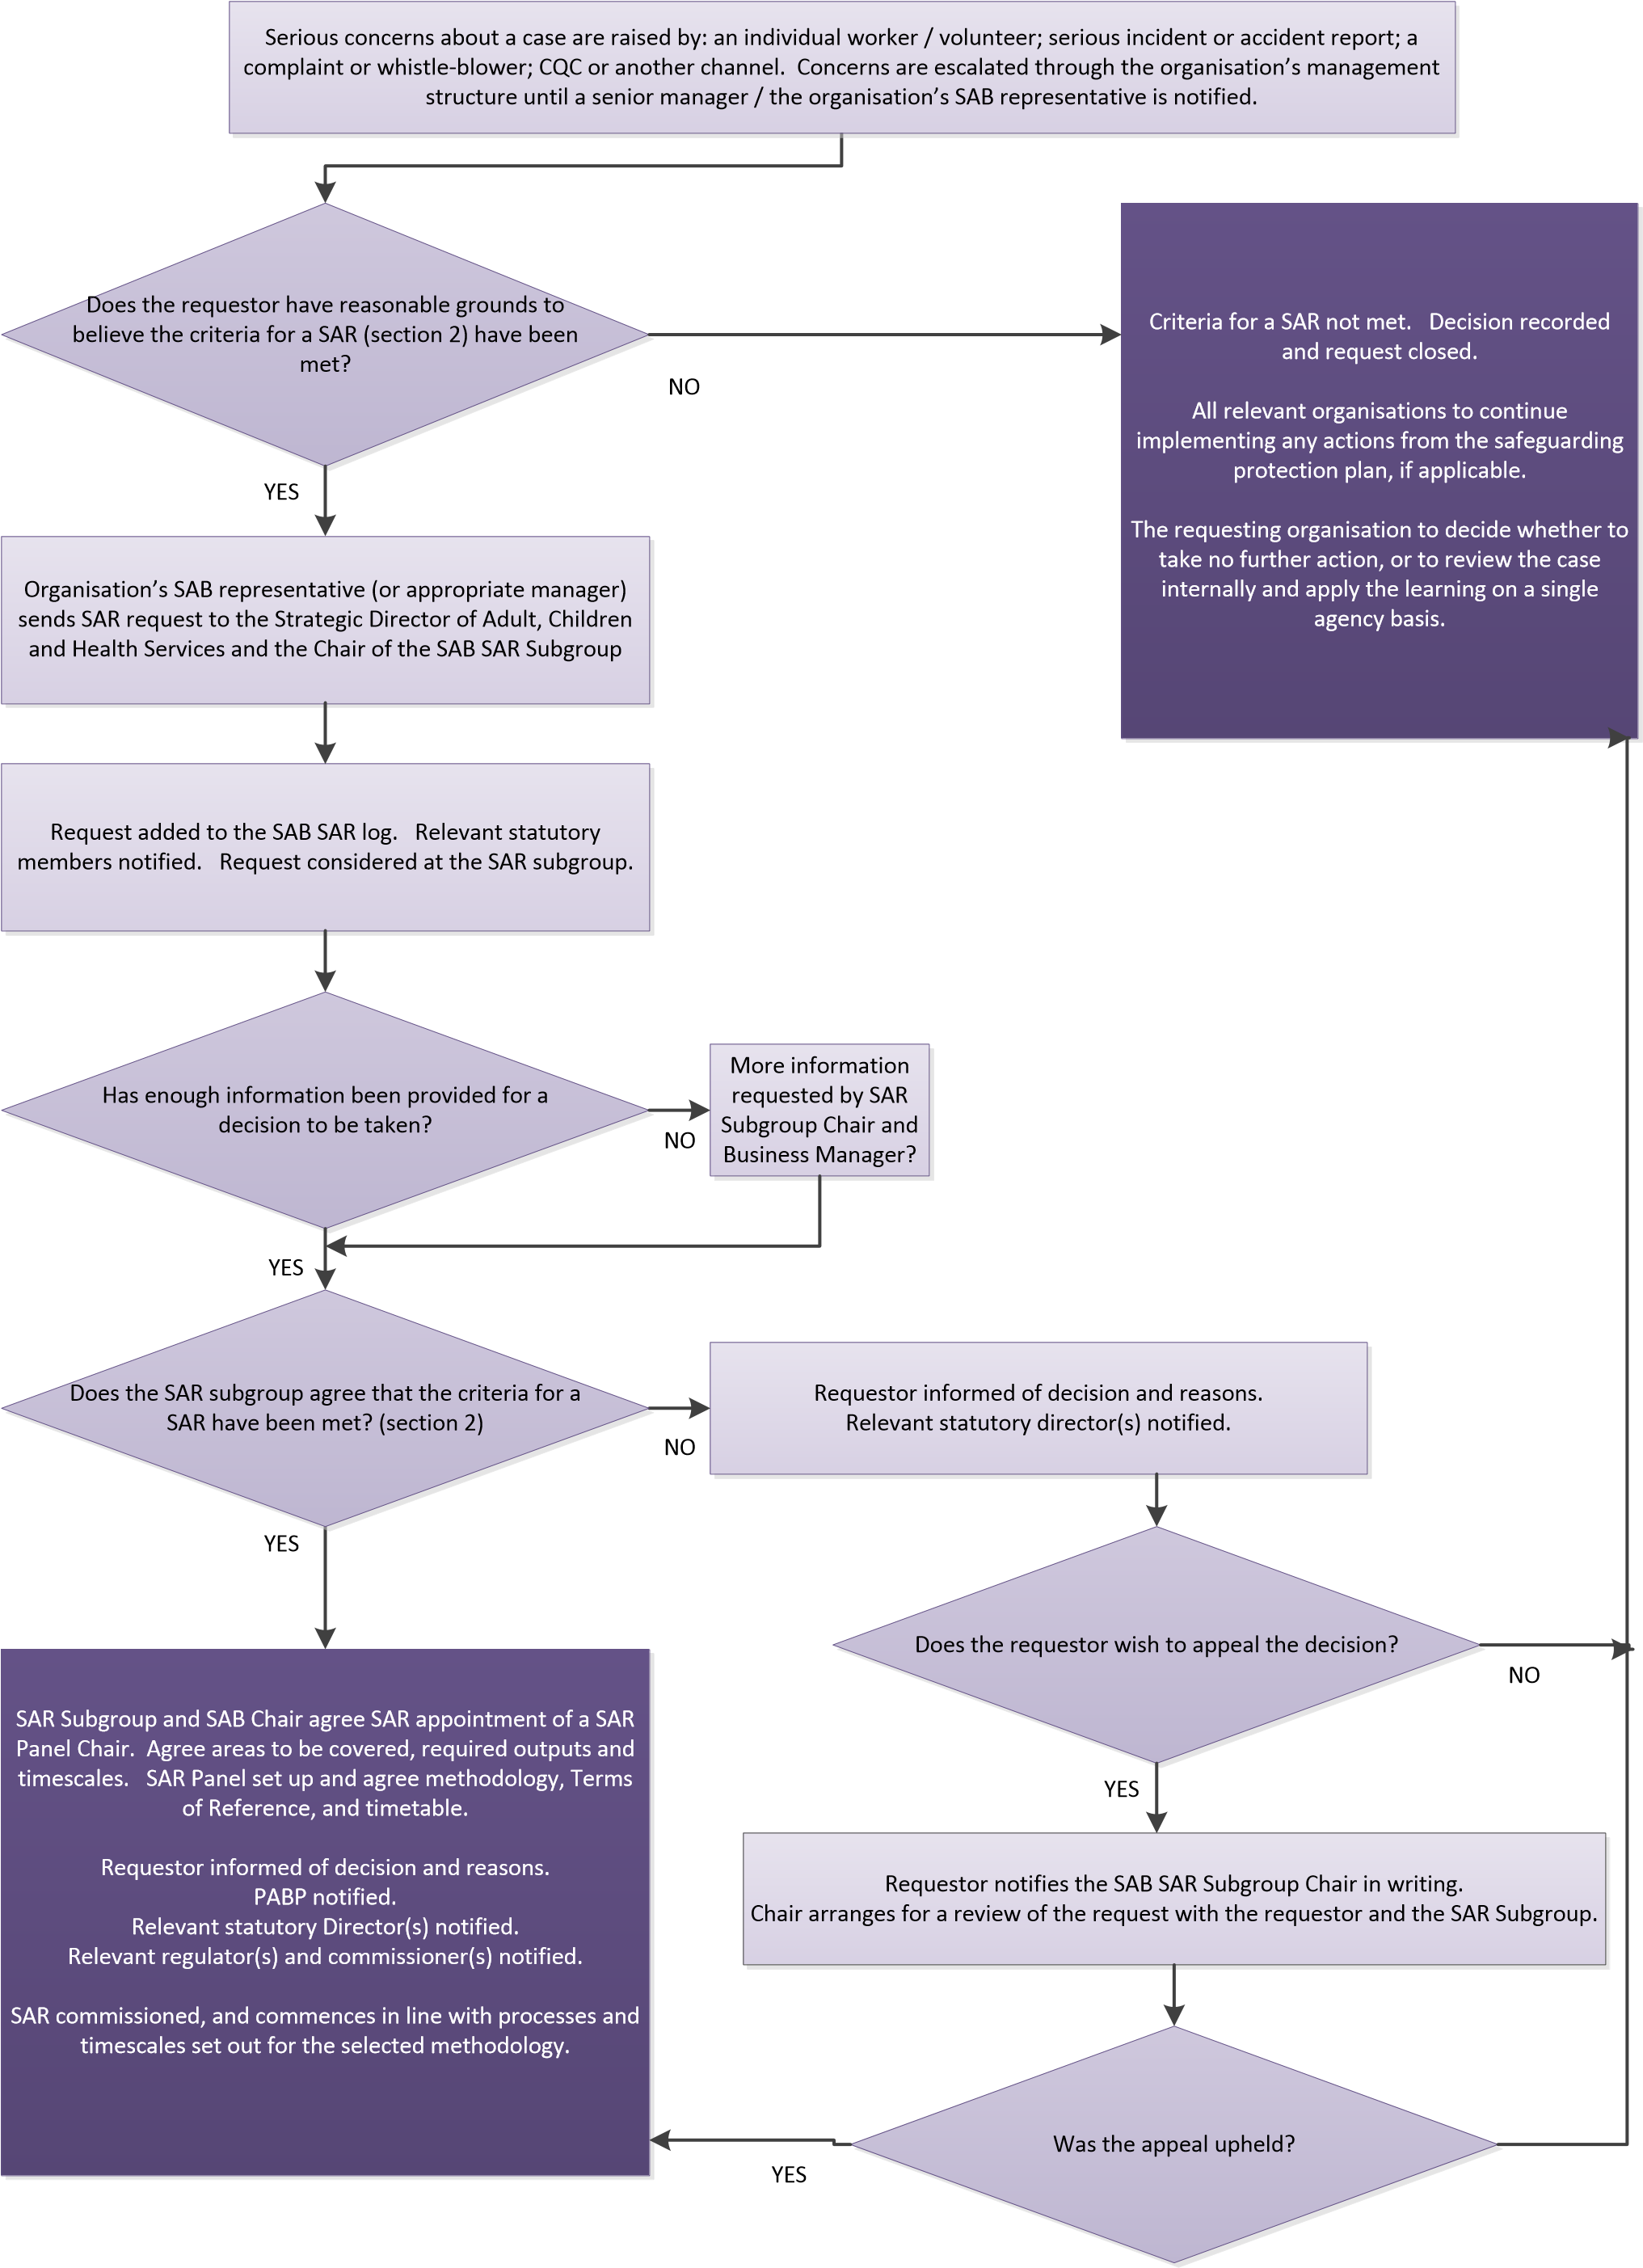

Appendix 2: Merton Safeguarding Adults Board Safeguarding Adults Review request form

SAFEGUARDING ADULT REVIEW (SAR) REFERRAL FORM
PART 1

Identifying information
Name(s) of person being referred:

DOB:

Address:

Ethnicity:

Date of death (if relevant):

Cause of death (if relevant/known):

Name & address of GP (if known):

Family/Next of kin/Care worker/Advocate/Representative:

Location & date of incident:

Referral information
Name(s) (of person making referral):

Date of your referral:

Name of your agency:

Your position:

Your email:

Your telephone number:

Submission details
By email:  msab@merton.gov.uk | By post:  Safeguarding Adults Team  London Borough of Merton  Merton Civic Centre  London Road  Morden SM4 5DX

PART 2

Reason for referral
Why are you referring this case for a Safeguarding Adult Review?
In making your referral, you should consult the local policy, setting out your reasons as to why the criteria is met.

2.1 The Care Act 2017 and the London Multi Agency Safeguarding Adults Policies and Procedures are set out when a Safeguarding Adults Board (MSAB) must conduct a SAR. The criteria for a SAR are met when:
- An adult at risk dies (including suicide) and abuse or neglect is known or suspected to be a factor in their death and there is a concern that partner agencies could have worked more effectively together to protect the adult.
- An adult at risk, still alive, has sustained injury and/or experienced significant abuse or neglect and there is a concern that partner agencies could have worked more effectively together to protect the adult.
- Serious or apparently systematic abuse has taken place in an institution or when multiple abusers are involved.

Your brief but clear summary of the case:
(Including notes of any Safeguarding meetings held)
Other agencies known to be involved:

Any other information you deem to be necessary:
Identify the factors that suggest this case meets the criteria for a SAR:

For use of the SAR Evaluation Group only
Date referral received:
Date considered by SAR Evaluation Group:
Decision/Recommendation taken:
Date recommendation conveyed to the MSAB Chair:
MSAB Chair decision:

Appendix 3: Selecting the SAR methodology

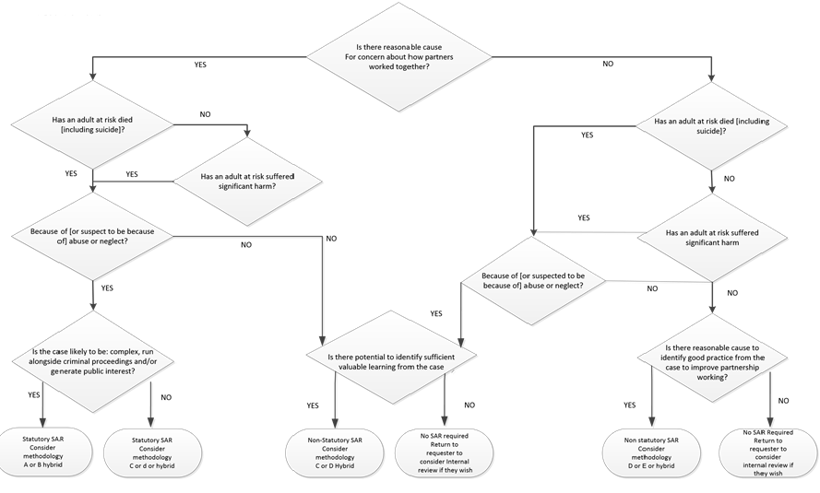

This is a selection of methodologies set out by SCIE. The MSAB will develop other methodologies using the components of these models as a toolkit.
These will be considered alongside the more traditional model of appointing a SAR Panel under an independent Chair; identifying IMR writers and producing an independent report as set out in appendix 6 based on panel discussion of the IMRs. This may be accompanied by other elements of the below methodologies.

Option A: Systems Analysis
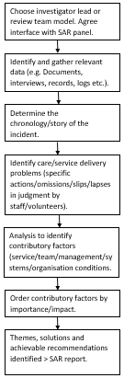
Key Features:
- Team/investigator led
- Looks at what happened and why, and reflect on gaps in
- Staff/adult/family involved via interviews
- No single agency management reports
- Integrated chronology
Advantages | Disadvantages
- Structured process of reflection  - Reduced burden on individual agencies to produce management reports  - Analysis from a team of reviewers may provide a more balanced view  - Managed approach to staff involvement may fit well where criminal investigations are ongoing  - Enables identification of multiple causes/contributory factors.  - Range of pre-existing analysis tools available  - Focusses on areas with greatest potential to cause future incidents  - Based on thorough academic research and review  - RCA tried and tested in healthcare and familiar to health sector SAB members | - Burden of analysis falls on small team/individual, rather than each agency contributing its own analysis via a management report. May result in reduced single agency ownership of learning/actions.  - Staff/family involvement limited to contributing data, not to analysis.  - Potential for data inconsistency/conflict, with no formal channel for clarification  - Unfamiliar process to most SAB members  - Trained reviewers not widely available  - Structured process may mean it is not light touch  - RCA may be more suited to single events/incidents and not complex multi-agency issues

Available models:
Vincent et. al. (2003) Systems analysis of clinical incidents: the London Protocol
Woloshynowych et. al. (2005) Investigation and analysis of critical incidents
NHS National Patient Safety Agency (NPSA) Root Cause Analysis
Option B: Learning Together

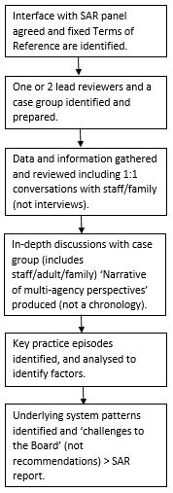

Key Features:
- Lead reviewer led, with case group  - Staff/adult/family involved visa case group and 1:1 conversations  - No single agency management reports | - Integrated narrative; no chronology  - Aims to identify underlying patterns/factors that support good practice or create safe conditions.

Advantages | Disadvantages
- Structured process of reflection  - Reduced burden on individual agencies to produce management reports  - Analysis from a team of reviewers and case group may provide a more balanced view  - Staff and volunteers participate fully in case group to provide information and test findings  - Enables identification of multiple causes/contributory factors  - Tried and tested in children’s safeguarding  - Pool of accredited independent reviewers available, and opportunity to train in-house reviewers to build capacity  - Range of pre-existing analysis tools available | - Burden of analysis falls on a small team/individual, rather than each agency contributing its own analysis via a management report. May results in reduced single agency ownership of learning/actions.  - Challenge of managing the process with large numbers of professionals/family involved.  - Wide staff involvement may not suit cases where criminal proceedings are ongoing and staff are witnesses.  - Cost – either to train in-house reviewers, or commission SCIE reviewers for each SAR.  - Opportunity costs or professionals spending large amounts of time in meetings?  - Unfamiliar process to most SAB members.  - Structured process may mean it is not light touch.

Available models:
SCIE, Learning Together

Option C: Significant Incident Learning Process
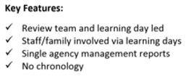
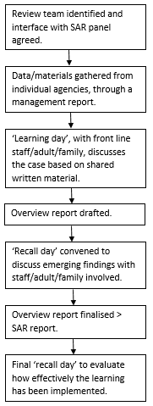

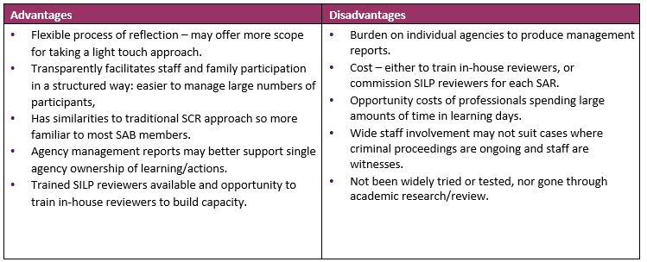

Option D: Significant Event Analysis
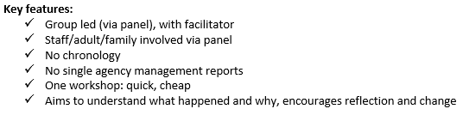
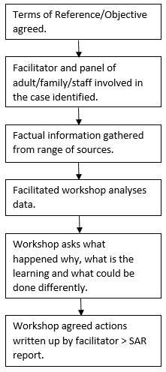

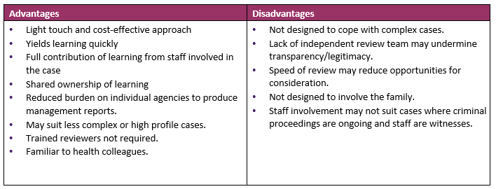

Available models:
NHS Education for Scotland and NPSA, Significant Event Analysis
Care Quality Commission, Significant Event Analysis
Royal College of General Practitioners, Significant Event Audit

Option E: Appreciative
Inquiry
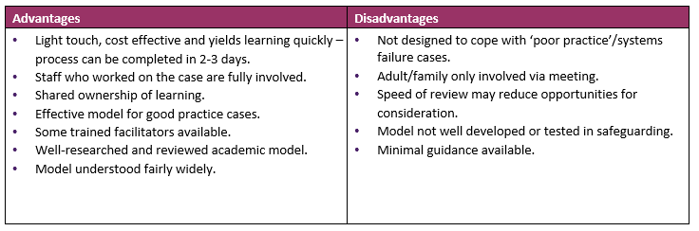
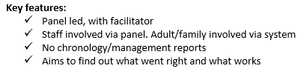
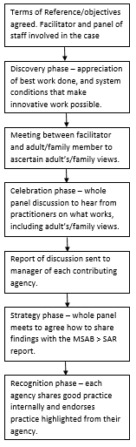

Appendix 4: Standard Letters
Standard letter A – response to SAR request.

Dear _______,
Re: Safeguarding Adults Review (SAR) for NAME & DOB
Thank you for the request for a Safeguarding Adults Review referral form for the above named client.
The SAR Evaluation Group (the group is made up of senior members from the Police, London Fire Brigade, Mental Health, Adult Social Care and CCG) have met and discussed the case and we are in the process of asking the relevant agencies for chronologies from the period _____ - _____. We aim to have this information back from __ weeks/days of the date of the request sent out and endeavour to decide at the next SAR Evaluation Group meeting.
Following this, a recommendation will be made to the Independent Chair of the Merton Safeguarding Adults Board and once the Chair has made a decision, you will be contacted with the outcome and with details of any action to be taken.
Please do not hesitate to contact if you have any questions or require further information.
Yours sincerely,

Chair of SAR Evaluation Group

Standard letter B – Notification to relevant agencies of SAR initiation.

RESTRICTED – Requires urgent attention
Dear
Re: Safeguarding Adults Review - name and date of birth of adult at risk, case file reference if known
A decision has been taken that the above named adult at risk is to be made the subject of a Safeguarding Adults Review (SAR), using _______ methodology. This will be undertaken in line with the Merton Safeguarding Adults Board (MSAB) SAR Framework
The purpose of this SAR is to establish whether there are any issues in relation to interagency working in line with the Merton Multi-Agency Safeguarding Adults Policy and Procedures, whether anything could have been done differently to predict or prevent the abuse and/or neglect, and whether there are any lessons to be learned to enhance partnership working, improve outcomes for adults and families, and prevent similar abuse and/or neglect occurring in the future. To achieve this, each agency that has had involvement with the family is required to look openly and critically at their professional practice with the adult at risk.
As Chair of the SAR Evaluation Subgroup to the MSAB, I am writing formally to request that you:
- Take action to ensure that your agency files in respect of the above named person are immediately secured to guard against potential loss or interference, and to enable the SAR process to commence. (if required, insert here details of any specific records that are affected – e.g. GP notes, home visit records etc.)
OR (delete as applicable)
- Identify a representative of sufficient seniority and experience from your organisation, and who is independent of the case in question, to sit on the SAR Panel and contribute to the review process. I would be grateful if you could forward to me the name and contact details of the appointed individual as soon as possible.
At this stage you and your organisation’s nominated representative may wish to familiarise yourselves with the Merton SAB SAR Framework and, in particular, the methodology that has been selected for this review. Given that a traditional SAR methodology has been selected, at this stage you may also wish to start identifying a manager (or independent person) of sufficient seniority and experience to undertake your individual management review. The manager appointed should have had no line management relationship with the practitioners working with the person, nor any direct contact with them themselves. Guidance on individual management reviews will be made available at a meeting of panel members and IMR writers early in a SAR process. All organisations contributing to a SAR need to be mindful that there may be public scrutiny of the information provided to the SAR by organisations and in particular, HM Coroner may request information. All organisations are therefore advised to ensure that senior managers approve any written submissions to the SAR, and where they consider it appropriate, seek legal advice prior to submission.
Thank you for your assistance in this important matter. Please do not hesitate to contact the SAB Business Manager or myself with any queries.

Yours sincerely

Chair of SAR Evaluation Group,

Appendix 5: SAR Terms of Reference & Confidentiality Statement

The Merton Safeguarding Adults Board Safeguarding Adults Review of
Code/Initials………………………………………..
Terms of Reference

Overarching aim and principles of the SAR
The purpose and underpinning principles of this SAR are set out in section 2.9 of the Multi- Agency Safeguarding Adults Policy and Procedures. All SAB members and organisations involved in this SAR, and all SAR panel members, agree to work to these aims and underpinning principles. The SAR is about identifying lessons to be learned across the partnership and not about establishing blame or culpability. In doing so, the SAR will take a broad approach to identifying causation, and will reflect the current realities of practice ("tell it like it is").

Legislation
Section 44 of the Care Act 2014 places a statutory requirement on Merton SAB to commission and learn from SARs in specific circumstances, as laid out below, and confers on the Board the power to commission a SAR into any other case:

A review of a case involving an adult in its area with needs for care and support (whether or not the local authority has been meeting any of those needs) if –
- there is reasonable cause for concern about how the SAB, members of it or other persons with relevant functions worked together to safeguard the adult, and
- the adult had died, and the SAB knows or suspects that the adult has experienced serious abuse or neglect., or
- the adult is still alive, and the SAB knows or suspects that the adult has experienced serious abuse or neglect. Each member of the SAB must co-operate in and contribute to the carrying out of a review under this section with a view to:-
- identifying the lessons to be learnt from the adult’s case, and
- applying those lessons to future cases.

Governance and accountability
This SAR will be conducted in accordance with the requirements set out in:
- Care Act 2014 and statutory guidance (DH 2014)
- Safeguarding Adults Reviews under the Care Act: implementation support (SCIE 2015)
- Multi-Agency Safeguarding Adults Policy and Procedures; and
- Merton SAR protocol

As the accountable body responsible for its commissioning, Merton SAB will receive updates on the progress of this SAR at Board meetings, or via offline written briefings as required.

SAR subjects (redact before publishing) The summary of details of the subject(s) of the SAR are:

Name | DoB | DoD | Age | Known and previous addresses
Subject
Name | DoB | DoD | Age | Known and previous addresses
Perpetrator(s)

Brief summary of the concerns that triggered this SAR

SAR methodology
XXXXXXXXXX has been selected as the methodology for conducting this SAR. This methodology has been selected because XXXXXXXXXX. Details of the methodology can be found in Safeguarding Adults Reviews under the Care Act:
implementation support

Specific areas of enquiry
The SAR Panel (and by extension all contributors) will consider and reflect on the following:
1.
2.
3.
4.
5.
The SAR should cover the time period dd/mm/yyyy to dd/mm/yyyy

Timescales for completion
This SAR will commence on dd/mm/yyyy and should be complete within six months. However, this may be affected any criminal proceedings and the review may be suspended pending any court case and resumed when any trial is concluded. Everyone involved in the SAR process must be mindful of not jeopardising any criminal proceedings.

Chair and membership of the SAR Panel
The chair and panel membership for this SAR have been determined as follows:

Name | Organisation | Secure email*
 | (SAR chair)
 | (SAR report author)
 | (Support Officer)

*In line with the confidentiality statement, all communication regarding this SAR that contains personal and / or sensitive information MUST be sent securely using the secure email addresses provided. Please contact the Business Manager with any queries regarding how to contact another panel member securely.

The independence of the chair from the case under review can be evidenced by XXXXXXXXXX.

The role and responsibilities of CCG and NHS England in relation to this SAR are particularly focused around enabling and facilitating engagement with health partners, and the identification and bringing together of key strategic themes and issues across the local health economy. (Delete/ adapt as applicable).

Administrative and professional support
The Business Manager will coordinate panel meetings and, where possible, circulate all documents at least five working days in advance of each meeting. Minutes will be taken by an appropriate officer.

Evidence and submissions to the SAR
It has been agreed that the following organisations are to submit evidence to the SAR:

Organisation | Nature of the evidence to be submitted | Deadline

SAR report and publication
XXXXXXXXXX has been appointed to author the SAR report, the content of which is to be in line with Merton SAB SAR Framework and the Merton Multi-Agency Safeguarding Adults Policy and Procedures. It must contain the transparency of analysis necessary for others to scrutinise the findings.
It is expected that an anonymised version of full SAR Report and/or an Executive Summary will be published on XXXXXXXXXX unless there are exceptional circumstances meaning this would not be appropriate. On completion of the report, the SAR Panel will discuss with the Merton SAB how to publish the report, setting out clear reasons for the any recommendations.
Timings for publication may be affected by any criminal proceedings and court cases, and the SAR report may be held for publication until such time as the proceedings / case(s) has concluded. In the meanwhile, any lessons learned can be taken forward immediately.

Involving and supporting the adult and family / friends / carers (redact before publishing)
The review will seek to involve the adult at risk and family/ friends/ carers (delete/ adapt as applicable) in this SAR.
OR
The SAR chair has agreed with the adult at risk and family/ friends/ carers (delete/ adapt as applicable) that they would/ would not like to be involved.

Name | Connection to the adult | Nature/timing of the involvement | Support agreed

The adult at risk and their family/friends/carers (delete/adapt as applicable) has indicated they would/would not (delete as applicable) like to be kept informed of progress/conclusions.

Involving and supporting key staff and volunteers
The review will seek to hear the perspectives of all key staff and volunteers by dd/mm/yyyy.
The SAR Panel member from each agency is responsible for identifying and notifying relevant staff and volunteers of this SAR and giving them the opportunity to share their views on the case.
The SAR Panel member from each agency is responsible for ensuring relevant staff and volunteers are provided with a safe environment to discuss their feelings and offered emotional support where needed, including counselling or other therapeutic support.

Disclosure and confidentiality
Confidentiality should be maintained by all SAB members and organisations involved in this SAR, in line with the confidentiality statement that forms part of these terms of reference.
However, the achievement of confidentiality must be balanced against the need for transparency and sharing of information in order for an effective SAR to be completed in the public interest, in line with Section 44 of the Care Act 2014, the Merton Multi-Agency Adult Safeguarding Policy and Procedures, and the Merton SAB SAR Framework.
All SAB member organisations involved in this SAR commit to co-operate in and contribute to this SAR, including sharing relevant information to support joint learning. Where it is suspected that critical information is not forthcoming, the Merton SAB may use its powers under Section 45 of the Care Act to obtain the relevant information. The Chair of the Merton SAB and/or the SAR chair may wish to review an organisation's case records and internal reports personally, request additional records and relevant policies/ guidance, or meet with review participants.

Criminal proceedings may be running in parallel to this SAR, and in such cases all material received by the SAR Panel must be disclosed to the police if and as requested.
Individuals will be granted anonymity within the SAR report and will be referred to by an alias as agreed by the SAR Panel.

Communications and media strategy
Communications advice will be provided and the communications approach managed in partnership with all relevant organisations. All media queries for cases involving criminal proceedings should be referred to Thames Valley Police.

Legal advice
Legal advice will be sought by the SAR Chair as required to ensure the SAR process and final report complies with legal requirements and safeguards all parties.

Liaison with the police, criminal justice system and coroner
There are no/ the following police or coroner's investigations ongoing linked to this case:
•

The SAR Chair has agreed the following arrangements to link the review and ongoing investigations:
•
•
•

The SAR Chair will be responsible for ensuring appropriate ongoing liaison with the Crown Prosecution Service, Coroner and the Police as required.

Links to parallel reviews
The SAR Panel has identified that this review links to *no other/ the following other ongoing statutory reviews:
•

The SAR Chair has agreed the following arrangements for dovetailing the reviews and reducing duplication:
•
•
•

The SAR Panel shall keep under review any links to other reviews of practice, such as domestic homicide reviews, serious incident reviews, children's Serious Case Reviews or a SAR being conducted by another SAB.

Funding and resourcing
It has been agreed that the funding of this SAR will be provided by

Review of Terms of Reference
In the light of information that becomes apparent, these Terms of Reference will be subject to review. Amendments to the terms of reference may be proposed as the SAR progresses but must be approved by the Chair of the Merton SAB.

Confidentiality Statement

The following confidentiality statement is to be read and signed by each SAR contributing agency representative, and returned to the Board Manager.
The Merton SAB Safeguarding Adults Review: Code/initials
I, the undersigned, confirm my understanding and acceptance of the following confidentiality requirements in relation to this SAR:
- All sensitive, personal and other information and documentation will be shared in the strictest confidence. It is expected that the duty of confidence will be maintained in line with the requirements of Data Protection legislation and local protocols for the sharing of information, including Caldicott requirements within Health and Social Care.
- All information received or given (including all documentation and notes, whether in electronic or hard copy form) must be held securely and safely. All material relating to the review must be kept together in one place. This includes information stored electronically which will normally be supplied in protected form.
- Electronic data may only be stored on agency systems. Memory sticks or other portable devices must not be used for this purpose.
- All documentation should be marked 'Confidential' and may not be disclosed to others without the prior written consent of the Chair of the SAR Panel or the Chair of the Merton SAB.
- All information discussed at any meetings as part of this review is and remains strictly confidential. It may not be discussed, disclosed or in any other way made available to other parties without the prior written consent of the Chair of the SAR Panel or the Chair of the Merton SAB.
- The unauthorised disclosure of information outside of meetings, beyond that which has been agreed and recorded within the minutes as part of this review, may have legal consequences. This would be considered a breach of the subject(s)'s confidentiality and a breach of the confidentiality requirements of the agencies involved and dealt with accordingly.
- All information and documentation supplied as part of the review is the property of the Merton SAB. It remains the confidential property of the Board even when stored within agency systems. All materials must be returned to the Chair of the Merton SAB on request, at the end of meetings, or at the end of the review process.
Advice on these requirements is available from the Business Manager of the Merton SAB.

Signed: …………………………………………………………………………………………………

Name: ………………………………………………………………………………………………….

Role: ………………………………………………………………………………………………….

Organisation: ………………………………………………………………………………………………….

Date: ………………………………………………………………………………………………….

Appendix 6: SAR report and Action Plan guidance and template

The SAR report must be delivered within timescales and according to the agreed terms of reference. The report must collate and analyse the information and evidence presented to the SAR Panel, highlight lessons learned and make practical recommendations on areas the safeguarding partnership should address to improve joint working and outcomes for adults and their families.

The report should:
- Provide a sound analysis of what happened, why and what action needs to be taken to prevent a reoccurrence, if possible;
- Include enough of the evidence, analysis and "working out" for the SAR Panel and the Merton SAB to scrutinise, critique and quality assure it;
- Be written in plain English; and
- Contain findings of practical value to organisations and professionals.
Templates for a report and SAB Action Plan are provided overleaf. As with all such reviews precise format that will be used depends on the features of the case and methodology used, and will be set in the terms of reference.
All contributing agencies or individuals will have the opportunity to ensure their information is fully and fairly represented in the report before it is presented to the Chair of the SAR Panel for comment and then to the full Board for approval and action planning.
The whole report or parts of it may be made available to partners and to the CQC if appropriate. The Overview Report may include an Executive Summary which may be made public.
The SAR Panel may propose a multi-agency action plan to append to the report, for discussion by the Merton SAB SAR Subgroup and which will be presented to each organisation for endorsement at senior level.

MERTON SAFEGUARDING ADULTS BOARD

SAFEGUARDING ADULTS REVIEW REPORT

Adult at risk male/ female: initials: case file reference: code

Date of birth

Date of death / age at time of incident
(all anonymised if appropriate)

Report Author including title, qualifications and organisation (if applicable)

Date of Report

1. Introduction
Give a summary of the aims of the report and the individual who is the subject of the review.
Clarify that the SAR has been conducted as either a statutory review under Section 44 of the Care Act, or as a non-statutory SAR as agreed by the MSAB SAR Subgroup. Set out that this SAR has been undertaken in line with the Multi-Agency Safeguarding Adults Policy and Procedures and with the MSAB's SAR Framework.
Clarify that the SAR is not intended to reinvestigate the case or apportion blame, but to learn lessons and make recommendations to improve practice, procedures and systems and ultimate improve the safeguarding and wellbeing of adults in the future.
2. The circumstances that led to a SAR being undertaken in this case.
Provide a brief and anonymous overview of the specific individual circumstances that led to a SAR being undertaken for this case.
Provide reasons for conducting the review and what SAR criteria were met (or if the criteria were not met the reason for conducting the review).
Provide outline of methodology to be used.
State decision (and date this was taken) to hold the SAR.

3. Terms of reference
State when the SAR commenced, details of the commissioner (usually independent Chair of the MSAB), SAR Chair and Panel members, and the report author.
State the dates the SAR Panel met and agreed terms of reference for the SAR.
List contributors to the review and the nature of their contributions. Cite contribution of family members/carers and any others. Include any communication with CQC or Government Offices. Set out how the involvement of staff and the adult/ family/ friends/carers was facilitated and supported (e.g. advocacy).
Identify the key issues within the SAR. Comment upon the quality of the evidence supplied and whether any action was required. Provide an explanation for any delay in completing the SAR in relation to the SAR framework and Terms of Reference.

4. Case summary: the facts
Provide a brief case summary including details of the incident, kind of maltreatment, who was believed responsible for the abuse. This should include:
- A pictorial display of the adult at risk's relationship to family members, extended family and household and any care services provided. Details provided should be brief and anonymous (as appropriate).
- An integrated chronology or narrative of agency involvement with the adult at risk, family/ carer on the part of all relevant organisations, professionals and others who have contributed to the review process. Note specifically in the chronology/ narrative each occasion on which the adult at risk was seen and the adult at risk's views and wishes sought or expressed.
- An overview that summarises what relevant information was known to the agencies and professionals involved about the carers, any perpetrator and the home circumstances of the adult at risk.

5. Analysis
Look at how and why events occurred, decisions made and actions taken/not taken Explain how events and conditions had looked to professionals at the time of the incident and in the period leading up to it.
Explore the range of contributory factors and systems conditions that played a part in causing the abuse or neglect.
Consider whether different decisions or actions may have led to an alternative course of events.
Consider how system conditions would have needed to be different to facilitate the different actions or decisions that would have been required.
Highlight any examples of good practice.

6. Conclusions and recommendations
Summarise, in the opinion of the SAR Panel, the key themes and patterns in the system arising from the SAR and what lessons can be drawn from the case.
Translate the lessons into recommendations for areas the MSAB should address to improve partnership working and outcomes for adult at risk at their families.
Recommendations should be few in number, focused and specific, and capable of being translated into an achievable action plan. Views on how the recommendations can be translated into action can be included. Consideration should be given to the resources required to implement the recommendations such as cost.
Recommendations should be divided into:
- Review - practice that should already be happening
- New - actions that need to be introduced and implemented.
If there are lessons for national, as well as local, policy and practice these should also be highlighted.

7. Proposed multi-agency action plan
The author and SAR Panel will provide a proposed set of actions for discussion, adoption and approval by the MSAB. The action plans should support the implementation of the recommendations identified in section 6 of the report. The actions identified should be multi-agency in nature: requiring the combined action of a number of partners in order to achieve them. Some single agency actions may be identified where these are vital to the implementation of the recommendations. The action plan should conclude with a statement on how the plan will be reviewed to determine if the outcomes have been achieved.
An example multi-agency action plan template is provided below:

SAR multi-agency action plan the Merton Safeguarding Adults Board

 | Identified action | Expected outcome | Evidence of completion | Barriers to implementation, and mitigations | Lead person / partner | Target Date | Progress
1
2
3
4
5
6
7
8
9
10

Guidelines for completing SAR action plans:
Identified actions should be focused and specific, and capable of being implemented. They can be actions that have or will be taken. Example actions may include: delivering training, developing new policies, introducing new standards, review working practices, etc.

Expected outcomes are the difference these changes will make to people in need of care and support / patients, and may include: referrals for safeguarding, quicker or better quality interventions, having to re-tell their story to fewer professionals, feeling safer etc.

Evidence of completion can be used to show the MSAB how actions are being undertaken or achieved, and may include: performance data, personal / patient feedback, minutes of meetings, new policies, training material, etc.

Barriers to implementation and mitigations is anything that may prevent/ hamper the partnership from taking the action forward, and what is being/ has been put in place to minimise the risk of the action not being progressed

Target date - provide the date action was completed and/or provide a realistic timescale for the partnership to address the identified action.

Progress column provides space for the partnership to record, monitor and report on the implementation of the actions - state whether the action is 'complete', 'in progress' or 'delayed'. If 'delayed' provide an updated target date. The partnership may use a RAG rating to monitor progress.

Appendix 7: Acknowledgements

Merton SAB would like to acknowledge the use of the following sources in the development of this SAR framework:

Camden Safeguarding Adults Partnership Board: Safeguarding Adults Review Framework 2015

Camden Safeguarding Children's Board (2014), Learning and Improvement Framework (unpublished).

Ibbetson, K. (2014), Alternative SCR methodologies and overview of useful literature (unpublished paper to Camden Safeguarding Children's Board).

ADASS (2013), Safeguarding Adults: Advice and Guidance to Directors of Adult Social Services

Bestjan, S. (2012) Serious safeguarding adults reviews: guidance note on options for London

Bowie, P., and Pringle, M., (2008), Significant Event Audit: Guidance for Primary Care Teams

Department of Health (2014), Care and Support Statutory Guidance Issued under the Care Act 2014

Fish, S., Munro, E., and Bairstow, Learning together to safeguard children: developing a multi-agency systems approach for case reviews

Fish, S., Munro, E., and Bairstow, S. (2010), Piloting the SCIE systems model for case reviews

Gateshead Safeguarding Adults Board (2013) Safeguarding Adults Review Protocol

Hampshire Safeguarding Adults Board (2014), Multi-Agency Learning and Review Framework: Learning from Experience to Improve Practice.

Leeds Safeguarding Adults Board (2013),Leeds SAB Safeguarding Adults Review Policy and Toolkit

London ADASS Improvement Team (2015), London Multi-Agency Safeguarding Adults Policy and Procedures (draft).

Munro, E., and Lushey, C. (2013), Undertaking SCRs using the SCIE Learning Together model - lessons from the pilots (Childhood Wellbeing Research Centre).

SCIE (2015), Safeguarding Adults Reviews under the Care Act: implementation support.

UK Parliament (2014), Care Act 2014.

West Midlands Region (undated), Safeguarding Adults Case Review Framework (unpublished).

Care and Support Statutory Guidance issued under the Care Act, 2014, paragraphs 14.133 to 14.149 https://www.gov.uk/government/uploads/system/uploads/attachment_data/file/366104/43380_23902777_Care_Act_Book.p df

