Corona Virus Disease (COVID-19)
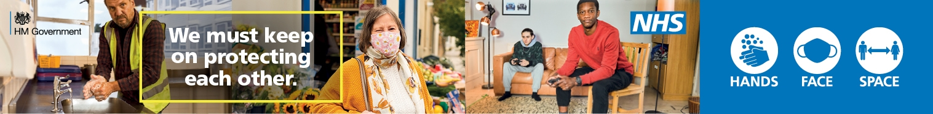
As COVID-19 infection levels are increasing across the capital and the country the UK alert level has increased from three to four, signalling a high or an exponentially rising level of transmission. The new government guidance sets out a longer-term view of how the country will continue to live and work with the virus in circulation for at least the next six months. It is important to continue to receive and share accurate information, so that you can take the necessary steps to keep yourself, your family and those you care for safe.
This page provides residents, carers and professionals with accurate information sources so that everyone in Merton can help themselves to keep safe and well.
The precautions and advice we should all follow can change rapidly, ensure you keep up to date with what you need to do to protect yourself and others by reading the latest advice from the Government UK.

Safeguarding During COVID-19
Safeguarding adults remains a statutory duty of local authorities to keep everyone safe from abuse or neglect. The Coronavirus Act 2020 does not affect the safeguarding protections in the Care Act, particularly at Section 42 of the Care Act. It is vital that local authorities continue to offer the same level of safeguarding oversight and application of Section 42. However, it is also important that the safeguarding team and practitioners are proportionate in their responses and mindful of the pressure social care providers are likely to be under.
The Coronavirus Act 2020 also made it clear that there is a duty to continue to undertake safeguarding work, Section 44 Safeguarding Adult Reviews. More information on the Care Act 2014 easements can be found further down the page.
Please don’t forget "Safeguarding is everyone’s business" so it is important that we all remain alert to possible abuse or neglect concerns.
If you are concerned about yourself or anyone that you care about may be at risk of abuse or neglect please call the First Response Team on 0208 545 4388/ out of hours 0845 618 9762 (24/7) email: ascfirstresponse@merton.gov.uk alternatively if you have concerns about the immediate safety of an adult at risk then please contact the Police in an emergency on 999 or non-emergency 101.
Care Act easements: Guidance for Local Authorities
This guidance sets out how Local Authorities can use the new Care Act easements, created under the Coronavirus Act 2020, to ensure the best possible care for people in our society during this exceptional period.
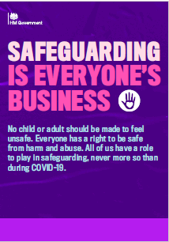

Domestic Abuse - Safeguarding is Everyone's Business Leaflet - gov.uk
No child or adult should be made to feel unsafe. Everyone has a right to be safe from harm and abuse. All of us have a role to play in safeguarding, never more so than during COVID-19. The UK Government has published a new leaflet which gives updated and specific safeguarding information and advice during the COVID-19 outbreak.

Social Distancing and Self-Isolation – Increased Risk
We know that social isolation is an increasing risk factor in relation to abuse and neglect. In particular, we know that incidences of domestic abuse, self-neglect and carer stress will increase with social isolation. With more people being asked to self-isolate as a result Covid-19 this needs to be a key consideration. Social isolation can mean:
- Abuse/neglect is hidden from professionals or others;
- People do not get the support they need;
- People feel like they do not want to ask for help for fear of being an added burden;
- Increased household stress and tension;
- People ask for help from people who might want to take advantage of their vulnerable position.

