INVITATION TO ATTEND
NHS Safeguarding Learning Together Week
Adult Safeguarding
21 November 2022 – 25 November 2022
12noon to 1pm each day
NHS Safeguarding are pleased to invite you to a week to effect change.
We have fabulous speakers who will be presenting on Adult Safeguarding
Anyone can join, so feel free to share this invitation with your colleagues and friends.
Please join us on the safeguarding FutureNHS workspace. No registration required.
Date | Topic | Speakers
Monday 21 November 2022  Host: Cathy Sheehan  Join on the day link here | - Scams targeting the vulnerable | Professor Keith Brown  Chair of the Safeguarding Adults Network
Tuesday 22 November 2022  Host: Catherine Randall  Join on the day link here | - Self-Neglect  - Hoarding | David Harling  National Deputy Director for Learning Disability Nursing  Donna Bentley  National Fire Chief Council Strategic Lead Safeguarding
Wednesday 23 November 2022  Host: Becs Reynolds  Join on the day link here | - FGM  - Forced marriage  - Virginity Testing and  Hymenoplasty | Dr Sharon Dixon  GP  Dr Bryony Kendall  Named GP for Safeguarding  Donna Love  Safeguarding Programme Manager
Thursday 24 November 2022  Host: Cathy Sheehan  Join on the day link here | - Priorities of the work of a social worker  - New ways of working between social care and ICB/ICP  - Improving safeguarding for adults together | Lyn Romeo  Chief Social Worker for Adults, England
Friday 25 November 2022  Host: Kenny Gibson  Join on the day link here | - Mental Capacity Act (MCA)  - Liberty Protection Safeguards (LPS) | Nikki Sidgwick  Transforming Care Resettlement Hub Case Manager  Chelle Farnan  Liberty Protection Safeguards Clinical Lead
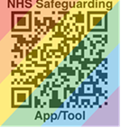
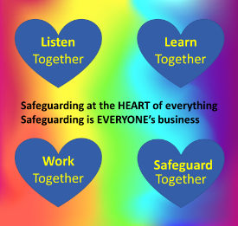
Follow us on @NHSsafeguarding for blogs and updates.
Tweet about it using:
#NHSsafeguarding
#teamCNO

